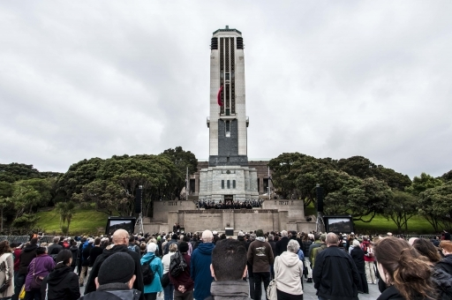
The view from Anzac Square during the opening ceremony for Pukeahu National War Memorial Park in April 2015 (Image courtesy of Douglas Styles/WW100 New Zealand)

French memorial planned for New Zealand capital Wellington
Posted on centenarynews.com on 09 December 2015
Share |
The ties forged between France and New Zealand during the First World War are to be commemorated with a monument in Pukeahu National War Memorial Park in Wellington.
Six prominent New Zealanders have been invited to France this week to discuss plans for the project.
An architectural competition is due to be launched by the French Embassy in Wellington in 2016.
The memorial, a gift from the French Government, will be inaugurated in New Zealand's capital in 2018 to mark the centenary of the end of the Great War.
France is hosting a joint symposium from December 6th-12th to agree a design brief.
The two countries say it will "focus on the 'big ideas' that the memorial should represent, leaving plenty of creative flexibility to the architects and designers to best represent them".
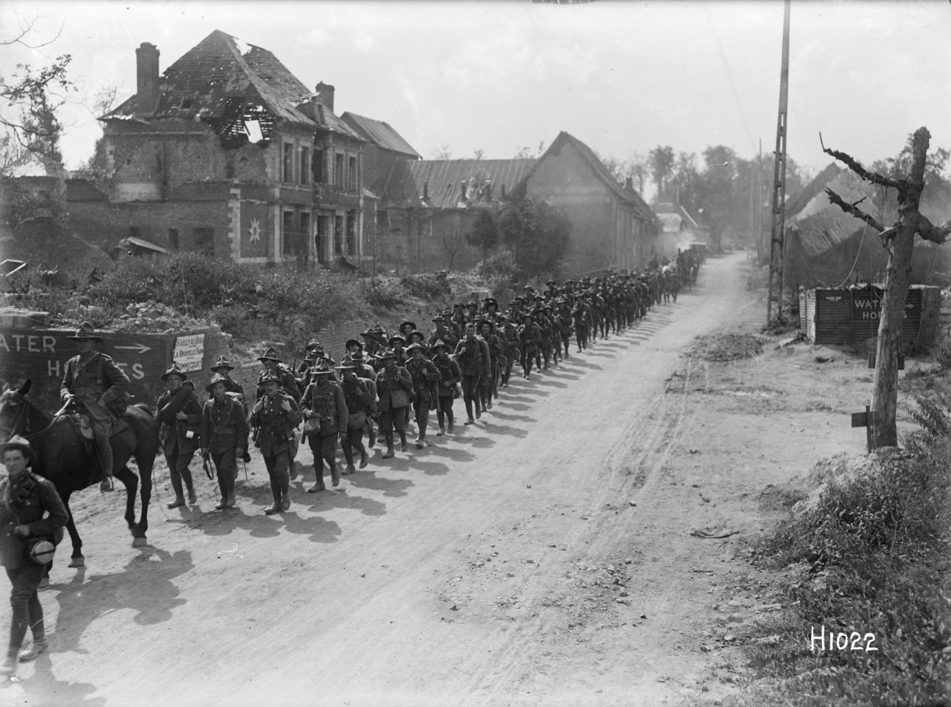
New Zealand troops marching though a residential area between Gommecourt and Sailly au Bois - photographed circa September 8th 1918 by Henry Armytage Sanders (Image: Alexander Turnbull Library)
Delegates are discussing how the peoples of France and New Zealand view their shared history of the war.
The New Zealanders, drawn from backgrounds including the military, architecture and the arts, are also touring significant Western Front remembrance sites as part of their visit.
The French memorial will be erected in Pukeahu National War Memorial Park at the invitation of the New Zealand Government.
Situated in the heart of Wellington, the park was opened in Anzac Week 2015 as New Zealand's centrepiece legacy project for the WW1 Centenary. Its title comes from a local Maori name, suggesting a 'sacred hill,' or place to perform rituals.
Read more on the New Zealand Ministry for Culture & Heritage/Manatū Taonga website.
Also in Centenary News:
Pukeahu National War Memorial Park opens.
Sources: New Zealand Government; French Embassy Wellington; Mission Centenaire 14-18
Images courtesy of Douglas Styles/WW100 New Zealand (Pukeahu opening ceremony); Alexander Turnbull Library Ref: 1/2-013587-G (NZ troops in France) .
Posted by: Peter Alhadeff, Centenary News

